**Installed App**

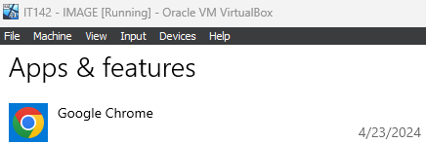

I decided to install Google Chrome on the system that I captured an image of.

**Sysprep**

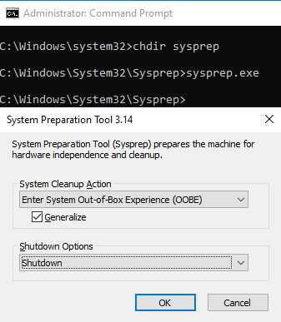

These are the commands and options I used to sysprep the system that I captured an image of.

**DISM Capture**

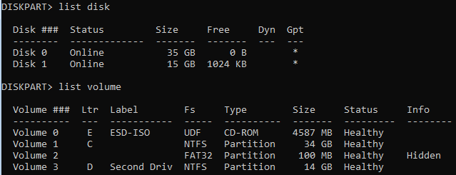

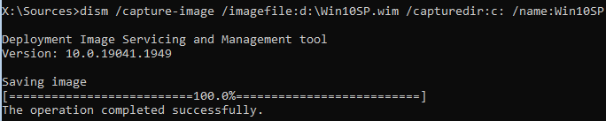

These are screenshots of the disks, volumes, and DISM command on the system that I captured an image of.

On this system, Disk 0/Volume C is what I want to capture, Disk 2/Volume D is where I want to capture the image to.

**DISM Apply**

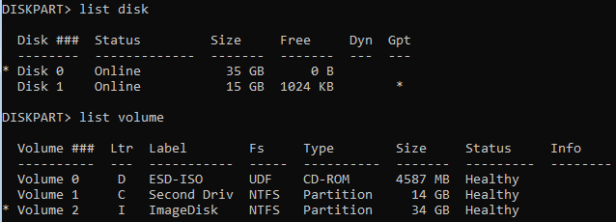

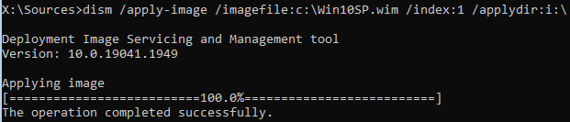

These are screenshots of the disks, volumes, and DISM command on the system that I applied the image to.

On this system, Disk 0/Volume C is where the image that I want to apply resides, and Disk 1/Volume I is where I want to apply the image.

**BCDBoot**



This is the BCDBoot command that I entered to create the boot files on the I drive.

**Image Applied**

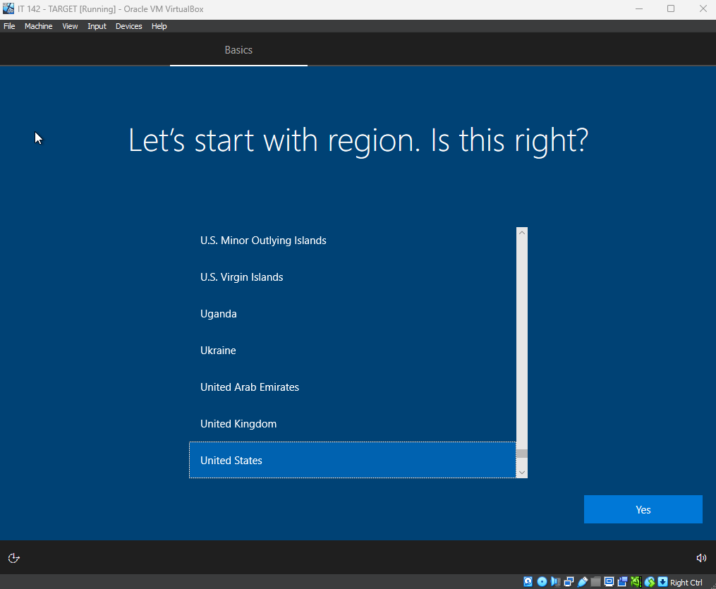

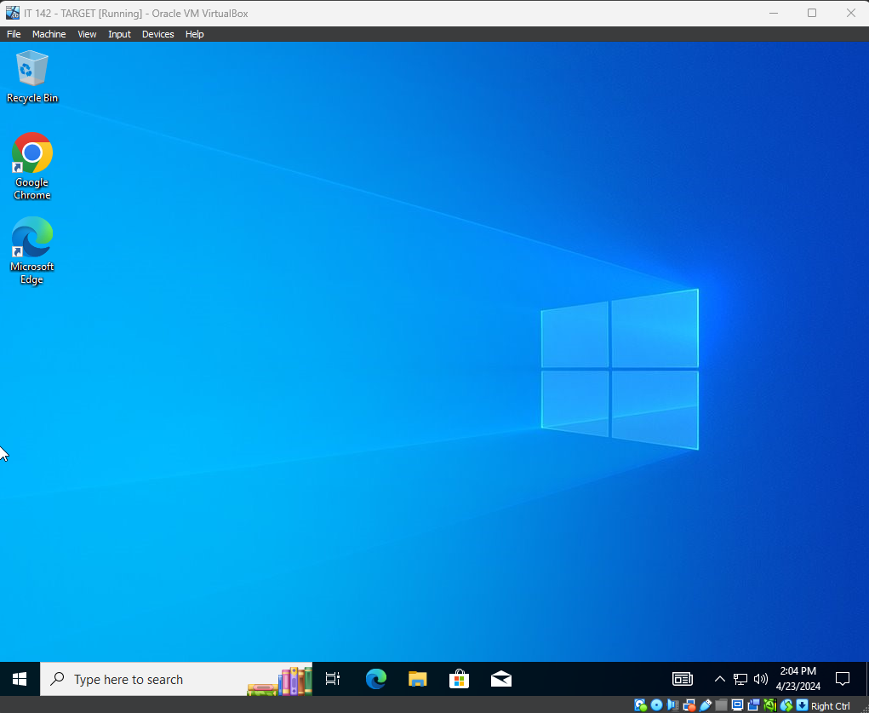

These images show what the system should look like after the image has been applied. Notice how it boots to the Out-Of-Box Experience, and shows Google Chrome already installed.